|  |  |
| --- | --- |
| \\VFILERDPI\DPI-Home\OBRIENR2\My Documents\Downloads\PP logo.jpg |  |
| **COUNCIL ASSESSMENT REPORT**  HUNTER AND CENTRAL COAST REGIONAL PLANNING PANEL | |

|  |  |
| --- | --- |
| PANEL REFERENCE & DA NUMBER | PPSHCC-189 - CENTRAL COAST DA/117/2023 |
| PROPOSAL | [brief description](as described in Schedule 1) |
| ADDRESS | Lot 2 DP1022771 63-69 LAKE ROAD TUGGERAH 2259 |
| APPLICANT | Mr Rod Wall |
| OWNER | Mr Wayne Jacobs & Mrs Cheryl Jacobs |
| DA LODGEMENT DATE | 21/04/2023 |
| APPLICATION TYPE (DA, Concept DA, CROWN DA, INTEGRATED, DESIGNATED) | Development Application – Designated Development |
| REGIONALLY SIGNIFICANT CRITERIA | Clause 7 (1)(c), Schedule 6 of the Planning Systems SEPP: Designated Development - Waste Facility |
| CIV | $51,826.00 (excluding GST) |
| CLAUSE 4.6 REQUESTS | Nil |
| KEY SEPP/LEP | * *SEPP (Planning Systems) 2021* * *SEPP (Resilience and Hazards) 2021* * *SEPP (Transport and Infrastructure) 2021* * *Central Coast Local Environmental Plan 2022* * Central Coast Development Control Plan 2022 |
| TOTAL & UNIQUE SUBMISSIONS KEY ISSUES IN SUBMISSIONS | One |
| DOCUMENTS SUBMITTED FOR CONSIDERATION | * Environmental Impact Statement - Resource Transfer Facility - Lot 2 DP-1022771 63-69 Lake Road Tuggerah NSW 2259   Annexure A – Site Location Map  Annexure B – Site Aerial Photograph  Annexure C – Site Plan & Elevations  Annexure D – Traffic Impact Assessment  Annexure E – Waste Management Plan  Annexure F – Flood Planning Certificate  Annexure G – Secretary’s Environmental Assessment Requirements (SEARs)  Annexure H – Aboriginal Heritage Information Management System Search Results  Annexure I – Air Quality Assessment  Annexure J – Noise & Vibration Assessment  Annexure K – Soil & Water Management Plan  Annexure L – Arborist Report  Annexure M – Development Cost Estimate   * PRELIMINARY SITE INVESTIGATION (PHASE I ENVIRONMENTAL SITE ASSESSMENT) WITH TARGETED SOIL SAMPLING AND TESTING, AND WATER QUALITY MONITORING PLAN - Lot 2 in DP1022771 63 – 69 Lake Road Tuggerah NSW 2259 * Survey Plan – Surface Detail Plan – Bisset and Wright 02/05/2024 * Updated Site Plan – 2022-15 DA01 – issue A.04 28/6/2024 * Operational Plan – Dumpers Skip Bins Central Coast |
| SPECIAL INFRASTRUCTURE CONTRIBUTIONS (S7.24) | N/A |
| RECOMMENDATION | Refusal |
| DRAFT CONDITIONS TO APPLICANT | N/A |
| SCHEDULED MEETING DATE | 11 December 2024 |
| PLAN VERSION | A.04 – 28/6/2024 |
| PREPARED BY | Nathan Burr |
| DATE OF REPORT | 4 December 2024 |

1. **THE SITE AND LOCALITY**
   1. **The Site**

The subject site is commonly known as 63-69 Lake Road, Tuggerah NSW 2259 and is legally described as Lot 2 DP1022771.

The allotment is regular in shape with frontage to Lake and Church Roads and comprises an area of approximately 4318m2. The site is zoned E4 General Industrial under the *Central Coast Local Environmental Plan 2022* (CCLEP 2022).

The site is generally flat and has been previously filled pursuant to development consent no. DA/1635/2000 issued by the former Wyong Shire Council to a level of approximately 3.50AHD. The site is generally cleared except for vegetation along the street frontages.

The fill pad is battered to the street frontages and an open swale catch drain is located at the top of the batters. Access to the site is via an existing concrete crossover adjoining Church Road in the southwestern corner of the site. There is an existing lightweight office building and a number of moveable building/shipping containers located on the site in additional to a number of bins and storage areas associated with the present use of the site as a waste or resource management facility. An extract of the survey plan is included below which depicts the existing buildings, vegetation, drainage and access.

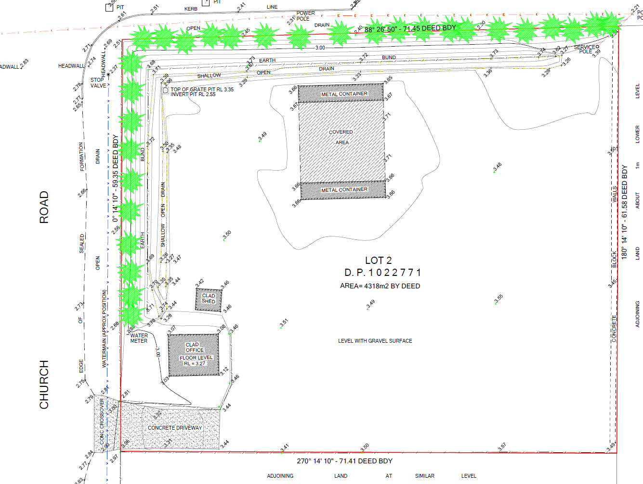

Figure 1 - Survey Plan

The CCLEP 2022 does not establish a maximum floor space ratio or a maximum building height. The site is class 3 potential or actual acid sulphate soils, is part bushfire prone and affected by the design level flood.

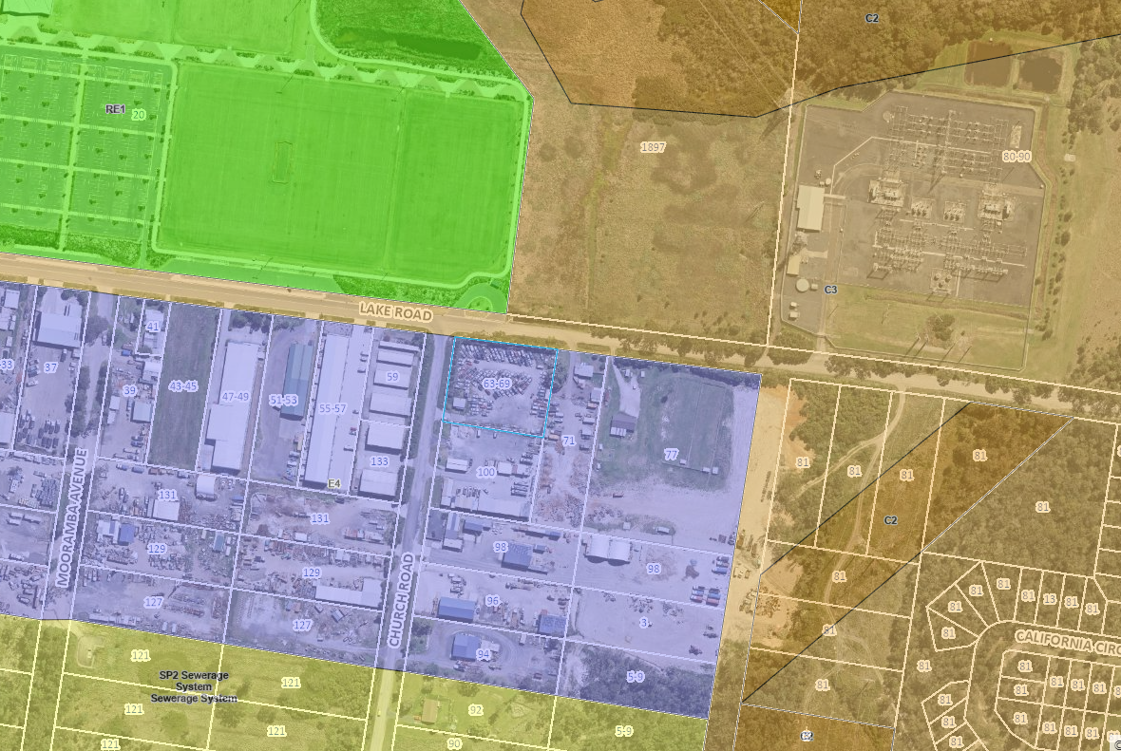

Figure 2 - CCLEP 2022 Zone Map of Site and Surrounds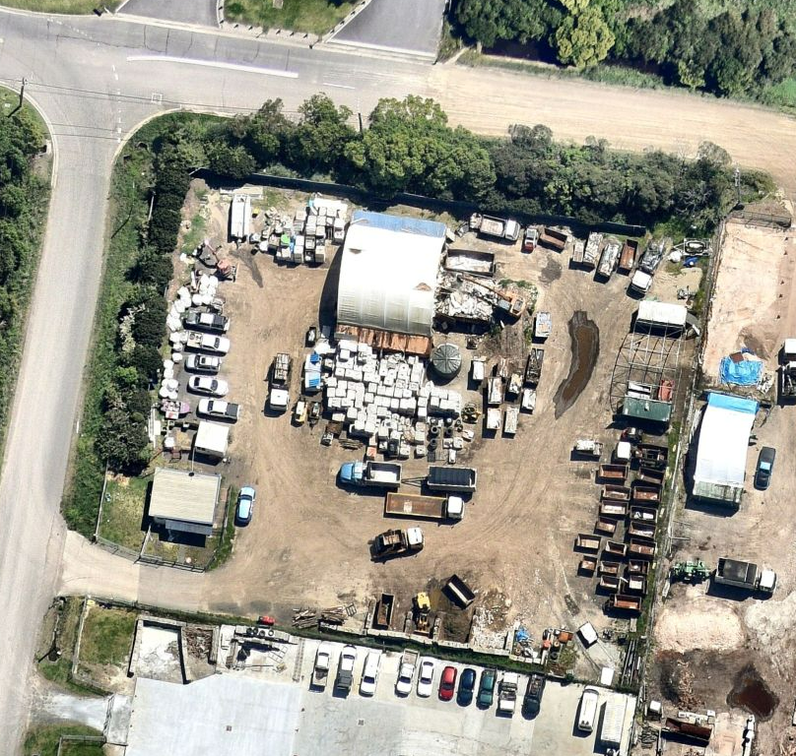

Figure 3 - Aerial photo 2024

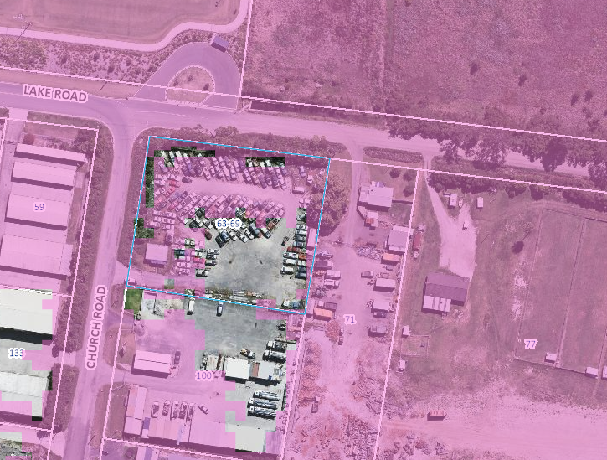

Figure 4 – Flood Planning Extent

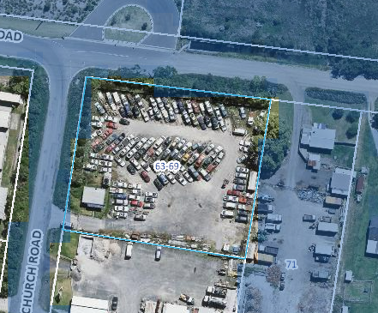

Figure 5 – 1% AEP Flood Extent

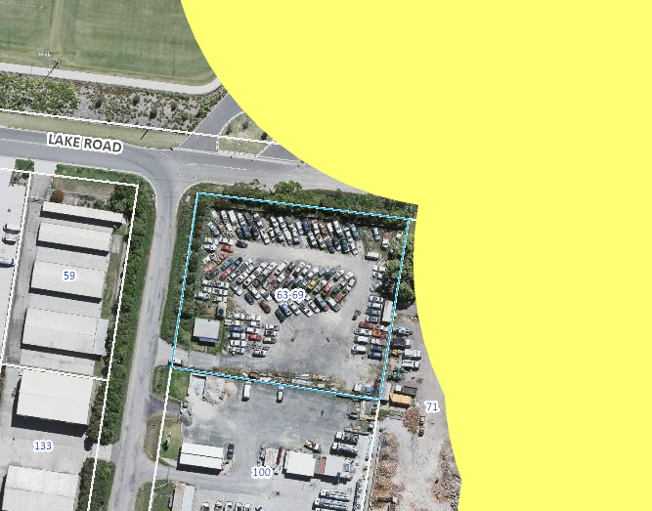

Figure 6 - Bushfire Prone Land Map

* 1. **The Locality**

The locality is one of varying uses. An existing dwelling is located on a lot adjoining the site on the Lake Road frontage. Properties along the southern side of Lake Road are utilised for a mixture of industrial and business development with some residential development also located along the frontage. Land to the north of Lake Road contains a regional sports facility and land known as Pioneer Dairy consisting of environmental and recreation lands. Other lots within local area are utilised for varying industrial uses such as depots and waste management facilities.

1. **THE PROPOSAL AND BACKGROUND** 
   1. **The Proposal**

The development application seeks consent for the construction and use of the site for a Waste or Resource Transfer Station and ancillary works which is identified as designated development under Schedule 3 of the *Environmental Planning and Assessment Regulation 2021*.

The Environmental Impact Statement and associated development application describe the proposed development as follows:

*The proposed development is designed to manage the recovery of building and construction waste materials. These materials will consist primarily of timber, brick and other common construction materials.*

There will be no handling of materials classified as hazardous or dangerous materials as part of the proposed development activities. Additionally, the proposed development will not include the handling of any chemical, liquid or biological waste materials.

*The proposed facility is intended to cater for approx. 5,000 tonnes of building and demolition waste on an annual basis and will has a projected maximum storage amount of approx. 35 tonnes of said materials on-site at any given point in time. It is important to recognise that the proposed development does not intend to process waste on-site, but rather recover, sort, prepare and relocate said materials to other sites wherein they can be either re-used, recycled or disposed of appropriately.*

*A general breakdown of the intended destination of various waste material types can be seen as follows.*

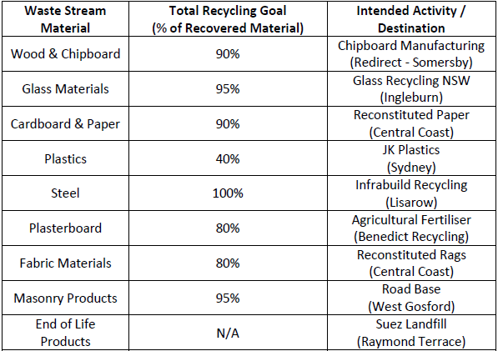

*The facility is to include the following:*

* *Covered “container-domed” waste tipping & sorting area (bunded) on the central-northern portion of the site.*
* *Storage Bays for general waste, timber waste, metal waste, brick rubble & skip bin storage (bunded).*
* *Refurbishment of the existing administration building containing office space and employee facilities.*
* Parking areas for staff, visitor and development vehicles.
* Localised sediment capture tank (for tipping area).
* Areas of the site dedicated to storage of skip bins (both empty and while awaiting dispatch).

*The general layout of the new facility will feature a tipping and sorting area in the central-northern part of the site, comprised of a bunded concrete slab sized at 144m2 which will be flanked and covered by a ‘container dome’ arrangement wherein two shipping containers sit alongside the concrete base and provide anchor points for an arched dome cover over the tipping area. This dome structure will be 12mx12m in area so as to provide coverage for the entire tipping and sorting area and will rest at a height of 6m above ground level at its apex.*

*In addition to the concrete slab and container dome structure, immediately adjacent to the tipping and sorting area a line of skip bins will be placed along the boundary, ready to receive various waste materials from the tipping area after they have been sorted. Once sorted and placed into the appropriate receptacles, the waste will be relocated from this location adjacent to the tipping and sorting area to other parts of the site, either to remain in skip bins temporarily until contracted recyclers collect the materials, or until disposal of the materials through appropriate waste streams has been organised…*

*In the specific case of masonry and brickwork materials that are recovered, the proposed development will also include several dedicated bays situated close to the southern boundary of the site for the storage of these materials. The storage bays will be constructed of non-load bearing concrete block walls on top of an additional smaller concrete slab with additional concrete block walls separating each of the material types.*

*Each of these storage bays will measure 4m in Length across the front facing x 2m in Width from front to back x 2m in height with potential volume of approx. 16m3. There will be a total of four of these storage bays included to accommodate for the masonry and aggregate materials recovered as part of facility operations. The storage bays will be covered by fixed corrugated iron roofing (colorbond style) so as to provide protection from the elements.*

*It is noted that these masonry materials, along with other types, will be stored on site only temporarily until arrangements are made for their dispatch to other waste stream operations.*

Hours of Operation:

Monday – Friday – 7.00AM – 5.00PM

Saturday – Sunday – Closed

Staff:

The proposed facility will employ 7 full time staff during its regular hours of operation.

Parking:

Eight Staff and Visitor car parking spaces are to be provided adjacent to the western boundary.

Extracts of the site plan and elevations are included below.

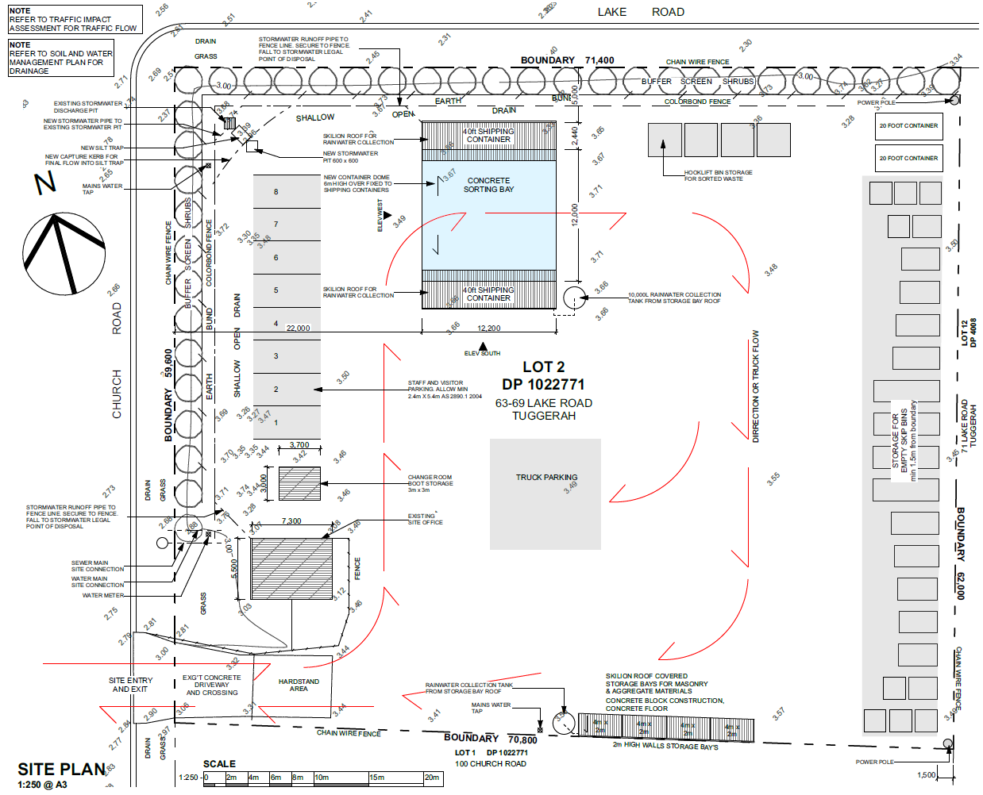

Figure 7 - Site Plan

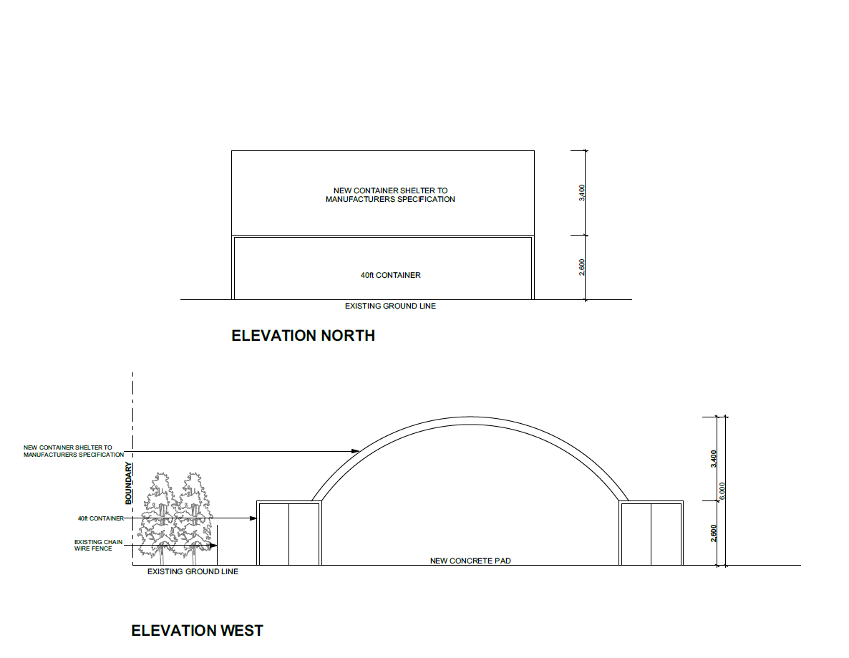

Figure 8 - Elevations

Photos of the site and awning structure are provided below have been extracted from the *Preliminary Site Investigation (Phase 1 Environmental Site Assessment) with Targeted Soil Sampling and testing, and Water Quality Monitoring Plan* submitted in support of the development application.

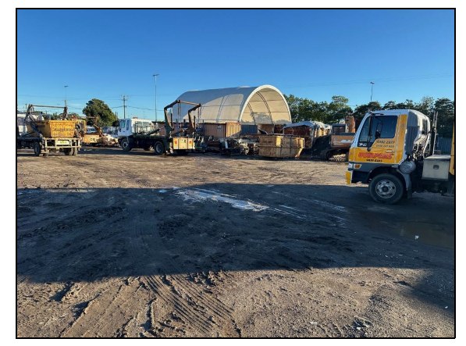

Photo 1 – Hardstand looking Northwest

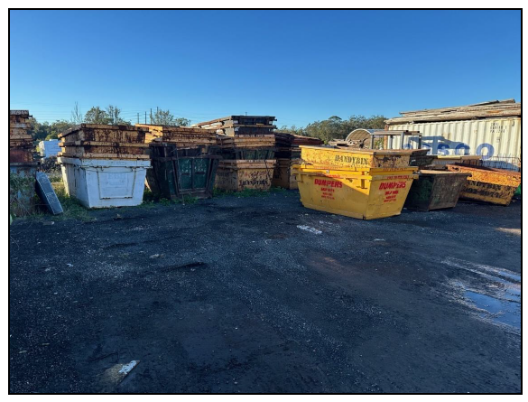

Photo 2 – Skip Bin Storage Area

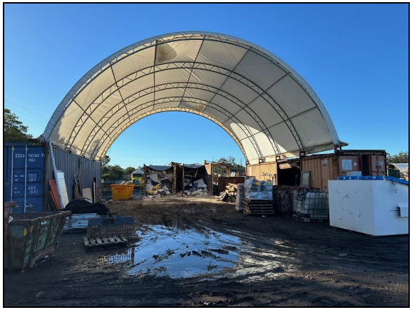

Photo 3 – Awning/Sorting Area

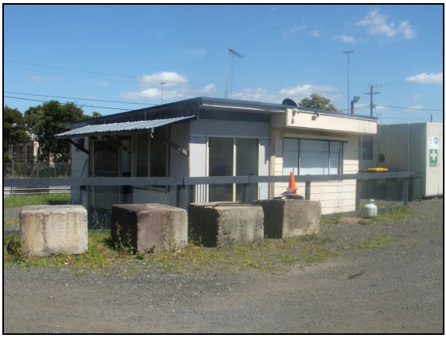

Photo 4 - Existing Office

* 1. **Site History**
* Clean Up Notice issued by former Wyong Shire Council 6 July 2005 in relation to an oil spill resulting in the removal of approximately 4 tons of soil.
* DA/819/2005 issued by the former Wyong Shire Council 10 May 2005 for use of the site as a truck holding yard.
* DA/1702/200 issued by the former Wyong Shire Council 18 October 2000 for the erection of a shed. A letter on the file indicates that works were physically commenced however, the approved shed was not constructed.
* DA/1635/2000 issued by the former Wyong Shire Council 18 September 2000 approving filling of the land to a level of approximately 3.50AHD. The filling works were subsequently carried out.

1. **STATUTORY CONSIDERATIONS**

When determining a development application, the consent authority must take into consideration the matters outlined in Section 4.15(1) of the *Environmental Planning and Assessment Act 1979* (‘EP&A Act’). These matters as are of relevance to the development application include the following:

1. *the provisions of any environmental planning instrument, proposed instrument, development control plan, planning agreement and the regulations*
2. *the likely impacts of that development, including environmental impacts on both the natural and built environments, and social and economic impacts in the locality,*
3. *the suitability of the site for the development,*
4. *any submissions made in accordance with this Act or the regulations,*
5. *the public interest.*

These matters are further considered below.

It is noted that the proposal is considered to be (which are considered further in this report):

* Designated Development (s4.10)
  1. **Section 4.15(1)(a)(i) - Provisions of Environmental Planning Instruments**

The following Environmental Planning Instruments are relevant to this application

* *State Environmental Planning Policy (Planning Systems) 2021*
* *State Environmental Planning Policy (Resilience and Hazards) 2021*
* *State Environmental Planning Policy (Transport and Infrastructure) 2021*
* *Central Coast Local Environmental Plan 2022;*

A summary of the key matters for consideration arising from these State Environmental

*State Environmental Planning Policy (Planning Systems) 2021*

Chapter 2: State and Regional Development

The proposal is *regionally significant development* pursuant to Section 2.19(1) as it satisfies the criteria in Clause 7(1)(c) of Schedule 6 of the Planning Systems SEPP as the proposal is designated development for the purposes of a waste facility. Accordingly, the Hunter and Central Coast Regional Planning Panel is the consent authority for this application.

The proposal is consistent with this Policy.

*State Environmental Planning Policy (Resilience and Hazards) 2021*

The relevant provisions of the SEPP are addressed as follows:

Chapter 3

The proposed development has been considered in the terms of the definitions contained in sections 3.2 and 3.3 and the development is not considered to be either potentially or actually a potentially hazardous or offensive storage or industrial development. In this regard while there have been a number of impacts associated with the proposed development these are not considered to be intrinsic to the proposed use and are considered to be able to be addressed via appropriate mitigation measures.

Chapter 4: Remediation of Land

The *Preliminary Site Investigation*, prepared by Larry Cook Consulting Pty Ltd, dated 24th June 2024 has been reviewed. The PSI does not meet the minimum requirements of the NSW EPA's contaminated site guidelines and cannot be supported for the following reasons:

* A conceptual site model has not been provided.
* Sampling for asbestos has not been carried out.
* Sampling was not conducted at the tipping area.
* Groundwater sampling has not been included in the assessment.
* Fill importation and resultant contaminants of concern have not been included,
* Soil stockpiles on the land have not been tested,
* Results of the site inspection and on-site observations including any areas of discoloration or signs of contamination have not been included in the investigation.
* Data gaps have not been included in the Investigation,
* Hotspot sampling has not been completed,
* A sampling and analysis plan has not been completed.

Given the site history there are considered to have been potentially contaminating activities carried out on the site and in the absence of any information to quantify the presence, or not, of contamination the consent authority cannot have considered whether the land is contaminated and accordingly consent cannot be granted to the development pursuant to the provisions of s.4.6(1)(a).

*State Environmental Planning Policy (Transport and Infrastructure) 2021*

Division 23 of SEPP (Transport and Infrastructure) 2021 relates to waste or resource management facilities and services to make the land use permissible in certain zones. In this instance the proposed development is permitted under the CCLEP 2022 within the subject zone and Division 23 has no work to do.

Section 2.122 and Schedule 3 of SEPP (Transport and Infrastructure) 2021 identifies traffic generating development as development specified Schedule 3 of the SEPP which includes *waste or resource management facilities* (in Column 1 of the table) of any size or capacity (in Column 2) where the site has a frontage to a road (generally).

A traffic Impact Assessment has been prepared for the proposal and supporting information were referred to Transport for NSW who note the existing poor level of service associated with the Bryant Drive and Wyong Road intersection but otherwise do not objection the proposal suggestion the development could benefit from the inclusion of a pollution control device at the access to prevent tracking.

The submitted traffic report indicates that the development will not have a detrimental impact on the local intersections. It is considered that the existing failure at the classified road is beyond the scope of the current proposal and in general the development is likely to have an acceptable impact on the road network. Pollution controls are discussed below.

***Central Coast Local Environmental Plan 2022***

The relevant local environmental plan applying to the site is the Central Coast *Local Environmental Plan 2022* (CCLEP 2022).

Zoning and Permissibility

The site is zoned E4 General Industrial under the CCLEP 2022. The proposed development is appropriately characterised as a waste or resource transfer station which is defined as follows:

***waste or resource transfer station*** *means a building or place used for the collection and transfer of waste material or resources, including the receipt, sorting, compacting, temporary storage and distribution of waste or resources and the loading or unloading of waste or resources onto or from road or rail transport.*

*Note—*

*Waste or resource transfer stations are a type of waste or resource management facility—see the definition of that term in this Dictionary.*

The proposed use of the site is consistent with the above definition in that goods are stored on the site until required offsite.

The objectives of the E4 zone are as follows:

* *To provide a range of industrial, warehouse, logistics and related land uses.*
* *To ensure the efficient and viable use of land for industrial uses.*
* *To minimise any adverse effect of industry on other land uses.*
* *To encourage employment opportunities.*
* *To enable limited non-industrial land uses that provide facilities and services to meet the needs of businesses and workers.*
* *To ensure that retail, commercial or service land uses in industrial areas are of an ancillary nature.*
* *To support and protect industrial land for industrial uses.*

The proposed development in terms of the scale and nature of the use is considered to be consistent with the objectives of the E4 zone however, the application fails on other grounds as discussed below.

General Controls and Development Standards (Parts 2, 4, 5 and 6)

The CCLEP 2022 contains controls relating to development standards, miscellaneous provisions, and local provisions. The relevant controls to the proposal are further set out in Table 5 below.

**Table .** Consideration of LEP controls.

|  |  |  |  |
| --- | --- | --- | --- |
| **Control** | **Requirement** | **Proposal** | **Comply** |
| Minimum subdivision lot size  (clause 4.1) | N/A | N/A | N/A |
| Height of Buildings (clause 4.3(2) | N/A | N/A | N/A |
| Floor Space Ratio  (clause 4.4(2) | N/A | N/A | N/A |
| Heritage  (clause 5.10) | N/A | N/A | N/A |
| Bushfire Hazard Reduction  (clause 5.11) | N/A | N/A | N/A |
| Flood Planning  (clause 5.21) | Development consent must not be granted to development on land the consent authority considers to be within the flood planning area unless particulars are demonstrated to be satisfied. | Discussed below. | Yes |
| Special Flood Considerations  (clause 5.22) | N/A | N/A | N/A |
| Acid Sulfate Soils (clause 7.1) | Development consent is required for the carrying of works described in the table in subclause 7.1(2). | Discussed below. | No |
| Essential Services  (clause 7.6) | The essential services are required to service the development – the supply of water, electricity, disposal and management of sewage, stormwater drainage, suitable vehicular access and the collection and management of waste. | Discussed below. | No |

Clause 5.21 – Flood Planning

The site is located within the Wyong River catchment and Council’s records indicate that the site is affected by flooding and/or minimum floor level requirements. In accordance with Council’s Online Flood Mapping Tool, and Flood Planning Certificate, the site is mapped as:

* Precinct 1: Probable Maximum Flood – across the southern section of the site
* Precinct 2: Flood Planning Area – across the northern and western sections of the site.

The flood planning certificate indicates that the 1% AEP flood level varies between 2.91mAHD and 2.94 mAHD. The detail site survey that has been submitted indicates the driveway levels around RL 3.32 mAHD, the existing office floor at RL 3.27 mAHD and the areas around the metal containers around RL3.66 mAHD. As such, the site is above the 1% AEP flood level.

Therefore, flood related development controls are not required for this development as stated in *CCLEP Clause 5.21 Flood Planning* and *CCDCP Chapter 3.1 Floodplain Management*.

In accordance with the Australian Institute for Disaster Resilience’s *Technical flood risk management guideline: Flood hazard* classifications, Church Street is impacted by a H1 hazard (i.e., generally safe for people, vehicles, and buildings) in the 1% AEP event, with a minor section of H2 flooding along Lake Road.

Safe pedestrian and vehicular evacuation from, and emergency vehicle access to, the site is available in the 1% AEP event. In the PMF event, this flood hazard is H5 on the site and along Lake Road and H4 and then H3 further to the west. As such, an Emergency Flood Evacuation Plan was submitted. The plan contains details on the potential flood hazards at the site, preparation actions, evacuation actions, and recovery activities.

Council’s Development Engineer is satisfied that the proposal does not increase the risk to life or impact to the existing evacuation requirements and the design generally avoids impacting on flood behaviour, hence the proposal is supported. In this regard, the Panel could be satisfied were consent to be granted that the proposed development, subject to conditions:

*(a)   is compatible with the flood function and behaviour on the land, and*

*(b)   will not adversely affect flood behaviour in a way that results in detrimental increases in the potential flood affectation of other development or properties, and*

*(c)   will not adversely affect the safe occupation and efficient evacuation of people or exceed the capacity of existing evacuation routes for the surrounding area in the event of a flood, and*

*(d)   incorporates appropriate measures to manage risk to life in the event of a flood, and*

*(e)   will not adversely affect the environment or cause avoidable erosion, siltation, destruction of riparian vegetation or a reduction in the stability of river banks or watercourses.*

Clause 7.1 – Acid Sulfate Soils

The land is mapped as class 3, high probability of occurrence of ASS soils one metre below the natural ground surface. A Preliminary ASS Assessment and/or an ASS Management Plan has not been provided. It is the view of Council’ Environmental Health Officer that there is insufficient design detail on the proposed ‘silt trap’ and the depth is not provided in order to determine if ASS will be disturbed during the proposed development and therefore considers that the development application has not met the precursor requirement of clause 7.1.

While it is considered that the ASS precursor requirement could be met through the provision of additional information the provision of this information must form part of the assessment and cannot be deferred to a condition of consent or the like and the consent authority is barred from granted consent in this instance.

Clause 7.6 -Essential Services

The consent authority must be satisfied that the proposed development has adequate essential servicing available to the development having regard for water, sewer, electricity, stormwater drainage, waste collection and vehicular access.

* Water and Sewer

A sewer diagram has submitted with the development application however, there are no details on what amenities are currently on the site and what is proposed to be used for the development. The site plan indicates mains water tap along the southern boundary, and an existing site office, however there is no further information on water amenities, such as toilets, kitchen sinks or laundry sinks. There is no water balance provided to address the water needs of the development in terms of the use of water to supress air pollution. The development application indicates that rainwater will be utilised for the suppression of air pollution however, contingencies are required for instances of drought or the like when there may be insufficient rainwater stored to meet the needs of the development. The incomplete information notwithstanding, there are existing reticulated services available to the site which are likely to meet the needs of the development.

* Electricity

Reticulated electricity is currently available to the site and the development application contains details of the location of the existing network such that no impacts are anticipated on existing infrastructure through the operation of the site or the access to the site.

* Stormwater Drainage

The stormwater management for the proposed development will use a silt and contamination device designed to treat water before discharge into the stormwater system. The Water Quality Monitoring Plan provides limited details on a proposed 1500L silt trap, however without any proposed drainage or site levelling works there is no explanation as to how the sites stormwater flows will be directed to the ‘silt trap’.

Sizing calculations for the ‘silt trap’ have not been provided. The proposed bunded areas to capture any polluted stormwater that enters the waste tipping area has not been depicted on the plans, nor has any drainage or priority treatment systems to remove any gross or fine pollutants within that area.

The development will have to manage stormwater runoff from the driveway and road areas and stormwater runoff from the contaminated / waste management areas. No modern style stormwater treatment systems have been proposed, such as gross pollutant traps and/or hydrocarbon filters. The updated site plan includes the following note at the roof of the existing site office “stormwater runoff pipe to fence line. Secure to fence. Fall too stormwater legal point of discharge”. No further details are provided.

The proposed roof coverage is not sufficient to prevent rainwater ingress into the waste tipping area to prevent stormwater from mixing with the waste and being transported offsite or filtering into the land resulting in land contamination.

The Operational plan submitted indicates the various waste streams that will be stockpiled on site however it is not clear if all of these will be stored in sealed containers or concreted areas, or on the ground in the open with no coverings. Section 6.10.1 of the original EIS stated that water would be used in dust suppression and cleaning operations only as required, however no further details on the potential location this would occur, or volume of water that would be used is included. Management of the runoff from this dust suppression would be required for water quality and quantity purposes.

Section 1.9 of the EIS states that as part of the proposed concrete tipping and sorting area, the proposed development will incorporate a silt trap & sump designed to capture and temporarily store dust and materials that are generated as part of sorting operations. The trap will be of very limited size and is not designed to allow for long term storage of materials. The storage device will be emptied regularly as part of daily operating procedures and the materials captured disposed of according to their nature. No further details on how this would occur, or how the waste form the silt trap would be managed, or removed or stored on site is included in the development application.

There is a 10,000 litre rainwater collection tank from the storage bay roof indicated on the site plan, and a rainwater collection tank from the storage bay roof on the southern boundary of the site however, there is no further information on where or what this rainwater is connected to for re-use on the site.

The Preliminary site investigation and water quality monitoring plan refers to periodic water sample testing to be undertaken during the operational phase of the development, as part of the water quality management plan. Water quality treatment will be required to be demonstrated through the use of a treatment train approach to manage the pollutants that are generated and will discharge from the site. Pollution control outcomes need to be defined by the applicant. Reference is made to section 10.3.5 of Council’s *Civil Works Specification 2020* for these requirements:

*“The Service Provider will be required to demonstrate by recognised modelling and other calculation that stormwater quality treatment objectives quoted in the Australian Runoff Quality - A Guide to Water Sensitive Design published by Engineers Australia can be met and maintained by implementation of a stormwater quality strategy for the Development.”*

The development application does not demonstrate that adequate stormwater drainage is or will be made available to the development and consent may not be granted to the development.

* Waste Collection

The proposed waste collection has been reviewed by Council’s Waste Officer who considered that the proposal would be satisfactory subject to conditions of consent were consent to be granted.

* Vehicular Access

There is an existing concrete driveway crossing form Lake Road to the site, along the southern boundary of the site. The dimensions of the existing driveway and vehicle access crossing to Church Road are not included on the plans however, the development application includes Heavy Rigid Vehicles and Medium Rigid Vehicles tracking to demonstrate suitable entry and exit to the site for the largest anticipated vehicle.

In this instance there are services available or services that could be made available to the development with the exception of stormwater drainage and further to the discussion above adequate stormwater drainage is not available and adequate arrangements have not been made to make it available and consent must therefore not be granted to the development.

* 1. **Section 4.15 (1)(a)(ii) - Provisions of any Proposed Instruments**

There are no proposed instruments that warrant discussion.

* 1. **Section 4.15(1)(a)(iii) - Provisions of any Development Control Plan**

The following Development Control Plan is relevant to this application:

* *Central Coast Development Control Plan 2022* (‘the DCP’)

*Chapter 2.13 – Parking and Access*

The above chapter does not have a specific parking requirement for waste or resource management facilities and as such parking requirements are merits based. The application proposes to have eight staff spaces on the site and no formalised parking area for the storage of vehicles associated with the business.

The business is to have up to seven staff members at any one time however it was not likely that all staff members would be on the site at the same time. The amount of staff parking is be considered to be suitable for the proposal given the number of staff however, there is little provision for visitors to the site and while it is stated there is to be no public visitation to the site were a vehicle to enter the site it would have limited space to park in addition to being required to either manoeuvre through the sorting area or against the designated traffic flow within the site.

It is not clear if the development will be paving or concreting or covering the existing ground. The updated site plan shows the driveway area of consisting of concrete and hardstand however, it is not clear what this hard stand actually is. The use of the term “hardstand area” is used throughout the application documents referring to various areas across the site. The type of site coverage will impact and influence the stormwater runoff characteristics from the site.

For example, hardstand materials and controls would need to be identified, e.g bitumen sealed surface with mitre drainage, Cement stabilised surface showing fall and siltation controls. If the existing site coverage is to be used, further geotechnical investigations will be required to support this approach, demonstrating it is fit for purpose and satisfies Councils DCP and Council’s *Civil Works Specification 2020* for vehicle access, manoeuvring, carparking and land use.

The DCP requires that vehicles are able to suitably manoeuvre on the site and parking surface areas are to be either concrete or sealed and the proposal does not adequately address the requirements of clause 2.13.4.6 which is likely to result in adverse water and air impacts through stormwater effects as mention, tracking of material from the site onto the local roads and through the generation of dust. .

*CCDCP 2022, Chapter 2.9 – Industrial Development*

The proposed development has been assessed against the provisions of chapter 2.9 and the proposal has been found to be generally acceptable in terms of the proposed setbacks, vegetative screening and the like however, the concerns raised in relation to the surface of the site and the potential impacts on water and air quality are repeated.

Council’s Environmental Health Officer has identified that the Acoustic Assessment does not identify, and list all proposed noisy plant and equipment intended to be used on the site or include on site vehicle/truck movements in the operational noise modelling to allow an adequate assessment that demonstrates compliance with the project specific noise criteria. As a result, the consent authority cannot be satisfied that the proposed activities achieve compliance with the *Noise Policy for Industry 2017* and that the activities will not result in offensive noise impacts to offsite receivers. The application has failed to address Clause 2.9.2.19 (Noise generation) of the DCP.

Clause 2.9.2.20 of the DCP requires development to incorporate fire mitigation and control measures. While the subject site is not bushfire prone land it is considered that consideration of fire safety, fire safety systems, safe storage and stockpiling of combustible waste material should be addressed by the development application.

*CCDCP 2022, Chapter 5.34 – Tuggerah Precinct*

The subject site is located within Area C1 and the DCP has controls relating to setbacks, FSR, site coverage, access and parking, built form, landscaping, roofscape, and signage. The proposal is considered generally consistent with these controls. The development will not be readily visible from Bryant Drive or Wyong Road. The existing landscaping is an effective screen the development and the buildings do not dominate the skyline.

* 1. **Section 4.15(1)(a)(iiia) – Planning agreements under Section 7.4 of the EP&A Act**

There have been no planning agreements entered into and there are no draft planning agreements being proposed for the site.

The proposal is consistent/inconsistent with this Planning Agreement as discussed in this report.

* 1. **Section 4.15(1)(a)(iv) - Provisions of Regulations**

The development is listed in Part 1 of Schedule 3 of the Regulation is Designated Development. The proposed development falls within clause 45 being Waste Management Facilities or Works under Schedule 3 of the Regulation which includes a *‘the facility or works sorts, consolidates or temporarily stores waste at a transfer station or material recycling facility for transfer to another site for final disposal, permanent storage, reprocessing, recycling, use or reuse’*. The goods and materials received, sorted and transferred at the subject premises do not meet the capacity for designated development of themselves however, the site is located in a floodplain, in proximity to an unrelated dwelling, on class 3 acid sulphate soils and is within proximity to a watercourse and therefore pursuant to Subclause (1) is deemed to be ‘Designated Development’.

Accordingly, an EIS has been prepared under Director General Requirements (DGR’s). The EIS generally responds to the DGR’s however, a number of merit issues have been identified through the assessment of the application which have been detailed in this report. One submission has been received raising concerns with the development which are outlined below.

* 1. **Section 4.15(1)(b) - Likely Impacts of Development**

The likely impacts of that development, including environmental impacts on both the natural and built environments, and social and economic impacts in the locality must be considered. In this regard, potential impacts related to the proposal have been considered in response to SEPPs, LEP and DCP controls outlined above and the Key Issues section below.

Built Environment

A thorough assessment of the aspects of the proposed development on the built environment has been undertaken in terms of DCP compliance. The development is generally acceptable in terms of the setbacks, building height and setbacks and subject to addressing the merit issues identified in this assessment the development could be made to have an acceptable impact on the locality.

Council’s Environmental Health Officer identified through inspection oof the site that the general condition of the administration building is dilapidated and suspected asbestos sheeting is exposed and in poor condition. Refurbishment of the structure is not supported as a Hazardous Materials Survey has not been submitted with the application. In order to support the development application a Hazardous Materials Survey is required that confirms that all hazardous building materials, such as asbestos, mineral fibres, lead paint etc is identified, safely removed by a licensed removalist, and replaced during the refurbishment.

*Noise*

A Noise and Vibration Assessment report has been prepared for the proposal which assessed the noise and vibration impacts during construction and operation including road traffic noise. As noted above with respect to compliance with the DCP Council’s Environmental Health Officer identified deficiencies in the submitted report and the potential noise impacts of the development can not be ascertained therefore.

*Stormwater and drainage*

As discussed in relation to clause 7.6 of CCLEP 2022 the proposed development does not adequately address water quality and it is considered that the development will have an adverse impact on water quality.

*Access, traffic and parking*

As discussed previously the development is likely to have an acceptable impact on the local road network however, concerns have been raised in relation to the suitability of the proposed surface utilised throughout the site and the air, water and manoeuvring impacts that may result from the development.

*Context and setting and public domain*

The proposal will not adversely impact on the character and amenity of the locality and streetscape. The scale, form, and character of the development is industrial and is considered acceptable within the locality given the industrial zoning of the area. The design and appearance of the development includes landscaped setbacks to all boundaries. The office building is single storey and the awning structure is lightweight in nature and characteristic of development within an industrial zone. .

*Earthworks*

The site levels have been established via historic works carried out with development development consent. The current proposal involves an area of soil disturbance exceeds 2500m2 and concept soil and water management plans are required to support the development application. Council’s Environmental Health Officer has reviewed the submitted ‘Soil and Water Management Plan’ and considers that the plan does not meet the requirements of the Landcom, ‘Blue book’ and does not adequately address the potential environmental impacts of sediment laden water discharging from the site.

*Aboriginal Cultural Heritage*

Aboriginal Cultural Heritage has been considered in the assessment of the proposal and a search of the Aboriginal Heritage Information Management System (AHIMS) did not identify any objects or sites within or immediately adjacent to the site. Given the context of the site and the extent of historic filling it is considered very unlikely that the development will result tin the harm of any culturally significant objects or sites.

*Air and microclimate*

An air quality impact assessment was prepared for the proposal to identify and assess the risks associated with impacts of potential sources of air and odour emissions associated with the development and to identify mitigation measures to be adopted as part of the development.

Notwithstanding, the open style tipping and sorting area is not supported due to the risk of wind-blown litter leaving the site and resulting in land and water pollution. The current and proposed site fencing (chain wire fence) is not considered to be satisfactory to prevent litter from being transported offsite during windy conditions.

*Safety, security and crime prevention*

The principles of Crime Prevention Through Environmental Design (CPTED) have been considered under the design of the proposed new development. The proposal incorporates a number of design considerations to discourage anti-social behaviour and minimise the opportunities for criminal activities:

* Improved casual surveillance opportunities on site and within the surrounding industrial estate. The vehicle entry also incorporates CCTV;
* A continued physical presence on the site;
* The subject site is fenced, and when not attended, all entry points and openings will be securely locked;
* Site fencing and new landscaping will delineate the site from surrounding publicly owned land. The physical spaces within the site have been designed such that they are able to be maintained so that the site will appear to be well kept and therefore deter crime.

*Environmental Management*

A Management Plan has been prepared to identify and manage the operation of the site and address potential pollution incidents.

The storage and disposal procedures for hazardous waste that enters the facility, notably asbestos within the construction waste, green waste, food product waste and the waste collected in the silt trap and sump ensuring that they will not be able to be conveyed by stormwater during rain events have not been addressed and concerns remain regarding the potential for the development to have an undue impact on water and air quality.

*Unauthorised structures*

There is an existing large awning structure installed on the site without approval which serves as the sorting area. A building information certificate has not been submitted in support of the current application.

*Natural Environment*

Council’s Ecologist conducted a preliminary biodiversity analysis of the site, in which the development footprint was assessed in accordance with the Biodiversity Values (BV) Map and Threshold Tool. The Biodiversity Values Map and Threshold Tool identifies land with high biodiversity value, particularly sensitive to impacts from development and clearing.

In this instance, the proposal does not intersect with mapped areas on the Biodiversity Values Map, nor will the proposed clearing breach the area clearing threshold under the Biodiversity Offsets Scheme.

An analysis of the vegetation present was completed by Council’s Ecologist, utilising Council’s Geospatial Data System. This analysis determined that the site is heavily disturbed and modified, and does not contain or boarder any significant, established vegetation communities.

Due to the broader historical ecological context, the Lake Road / Tuggerah Floodplain are known to support pockets of significant, Threatened Ecological Communities. Analysis of the surrounding area has indicated that there exists Plant Community Types consistent with the Threatened Ecological Community: Swamp Sclerophyll Forest on Coastal Floodplains of the NSW North Coast, Sydney Basin and South East Corner Bioregions (Endangered Ecological Community)

* Cabbage Gum - Forest Red Gum - Flax-leaved Paperbark Floodplain Forest of the Central Coast (PCT1720)
* Swamp Mahogany - Flax-leaved Paperbark swamp forest on coastal lowlands of the Central Coast (PCT 1718)

These Plant Communities have association with the Endangered Ecological Community Swamp Sclerophyll Forest on Coastal Floodplains of the NSW North Coast, Sydney Basin and Southeast Coast Bioregions. This mapped vegetation habitat, located to the west of the subject site is identified as being in “Moderate-Good” condition.

Council’s Geospatial Information System has identified these Plant Community Types as being situated to the east and southeast of the subject site. Additionally, this area is known to support the threatened species *Melaleuca biconvexa* (Biconvex Paperbark).

Threatened Species and Tree Impacts

Council’s Ecologist conducted a review of the Bionet Threatened Species Atlas which indicated the presence *of Melaleuca biconvexa* (Biconvex Paperbark) established along the Lake Road, road reserve, as well as through the Tuggerah Floodplain and down the road reserves along Church Road and Mooramba Road.

A review of the supporting Arborist Report indicates that all works will be avoiding impacts to trees, and existing tree protections provided by the current Colourbond fence is sufficient.

All stands of *Melaleuca biconvexa* are situated in the northern road reserve and will not be impacted by the proposal.

Should works be required to connect servicing to Lake Road, where impacts to *Melaleuca biconvexa* will occur. These services should be underbored / directionally drilled to avoid impacts to the root system, enabling the individuals to be retained.

No vegetation removal is supported in relation to the proposed development.

Accordingly, it is considered that the proposal will result in adverse impacts in the locality as outlined above.

* 1. **Section 4.15(1)(c) - Suitability of the site**

The site is located within an industrial area and has previously filled with consent to combat flood impacts in the locality. Despite broader traffic issues not associated with the proposed use, the development would take advantage of existing services. Subject to the development being reformulated to address the impacts identified in the consideration of the merits of the development the site is considered suitable to the scale and nature of the proposed development.

* 1. **Section 4.15(1)(d) - Public Submissions**

These submissions are considered in Section 5 of this report.

* 1. **Section 4.15(1)(e) - Public interest**

The assessment of the development application has identified several sources of potential pollution particularly in relation to water and air quality. The subject site is approximately 200m from a state significant wetland which makes potential water quality impacts a paramount consideration. In this instance while the development creates employment and provides a very desirable service to the community in light of the potential impacts the public interest is best served by refusing the development application.

1. **REFERRALS AND SUBMISSIONS** 
   1. **Agency Referrals and Concurrence**

The development application has been referred to various agencies for comment/concurrence/referral as required by the EP&A Act and outlined below.

The development application was referred to the NSW EPA who advised**;**

*-The proposal does not constitute a Scheduled Activity under Schedule 1 of the Protection of the Environment Operations Act (1997) and so, will not require an Environment Protection Licence under this Act,*

*-The proposal is not being undertaken by or on behalf of a NSW Public Authority, nor are there activities for which the EPA is the appropriate regulatory Authority.*

*-The site is not being regulated by the EPA under the Contaminated Land Management Act (1997).*

The development application was referred to Transport for NSW pursuant to SEPP T & I 2021 who advised that no objections were held in relation to the proposal but noted that there are existing poor levels of service associated with the nearby classified road and that the development would benefit from a pollution control device to reduce tracking from the site onto the local road network.

* 1. **Council Referrals**

The development application has been referred to various Council officers for technical review as outlined in the table below.

**Table 6: Consideration of Council Referrals**

|  |  |  |
| --- | --- | --- |
| **Officer** | **Comments** | **Resolved** |
| Engineering | Concerns raised in relation to vehicle access and manoeuvring, essential services particularly stormwater drainage. | No |
| Contributions | Contributions paid pursuant to previous consent and no further contributions are payable. | Yes |
| Water and Sewer | No objections raised. | Yes |
| Waste | No objection subject to compliance with the submitted waste plan. | Yes |
| Ecology | No objections subject to conditions of consent. | Yes |
| Trees | No objections to subject to conditions of consent | Yes |
| Environmental Health | Concerns raised in relation to the potential air and water impacts associated with the proposed use. Technical flaws identified in relation to the contamination and acoustic reports. | No |

The outstanding issues raised by Council officers are considered in the Key Issues section of this report.

* 1. **Community Consultation**

The proposal was notified in accordance with the provision related to Designate Development including a a minimum of 28 days exhibition period and the affixing a physical sign to the site. The proposal was exhibited from 5 May 2023 to 13 July 2023. One submission was received adjacent to but outside outside of the exhibition period. The matter raised in the public submission are included below.

1. *It is indicated the facility will handle a maximum of 5,000 tonnes of material per year. No weighbridge is indicated on the site so there is no easy method of confirming the tonnage handled. In most instances a check on weighbridge returns would allow a check on waste movement but as these are not available then strict conditions must be applied to require returns be submitted annually to Council from the operator detailing waste handled. Conditions should also require records be made available on site at ALL times, giving running totals and daily tonnage of waste to allow Council officers to assess compliance with waste limits. The development must not be allowed to move to Designated development through incremental waste handling without further assessment.*
2. *Skip bins adjacent to the sorting area and indicated to contain “various waste materials” do not appear to be covered to prevent entry of rainwater. These bins should be covered or provided with lids as water overflow may result in transfer of pollutants to the site stormwater system and hence the street drainage system.*
3. *Only the “dumping and sorting bay” has a silt trap and if this is the case then the bay area should be properly bunded to prevent site stormwater flowing through the bay in major storm events. If this occurs silt/waste transfer may occur.*
4. *The silt trap proposed for the “dumping and sorting bay” appears to be designed to contain only one day’s waste discharge. The EIS indicates that the trap will be cleaned daily, but this is considered inadequate. Any failure by staff to carry out the required cleaning, for whatever reason, would cause an unacceptable buildup of waste and possible discharge. The silt trap must be redesigned to contain at least four days potential material.*
5. *Inspection of the site shows a largely metal surface presently exists. The expected 23 truck movements per day (traffic study) will quickly impact this type of surface and encourage greater dust generation. The whole area should be hard sealed with either concrete or bitumen to reduce any impact.*
6. *At present Church Road is in a degraded condition. The expected truck movements require that the street be widened, upgraded and sealed from the intersection with Lake Road to the access driveway into the site.*
7. *The site presently drains to a single pit in the northwest corner. This pit has no silt control structure and simply discharges to the Council drainage system. In addition, the site is presently uneven, and water is ponding in various areas following periods of rain. Truck movements will increase the uneven nature of the site, promote greater ponding and hence increase soil and dust washing from vehicles entering the site. The whole site should be sealed and drained to properly constructed silt traps before any discharge of surface water to the outside drainage system and Tuggerah Lake.*
8. *The EIS indicates that ONLY building material will be accepted on the site and no putrescible waste will be accepted. It is extremely unlikely that there will not be some contamination of waste as has clearly been shown on other sites such as the Mangrove Mountain building waste landfill. The EIS does not indicate how any unacceptable waste which enters the waste stream will be dealt with. The applicant should be required to provide a detailed management plan for any putrescible waste which enters the site.*

There have been contributions paid in association with past development for the upgrade of the local road network and there have been no specific issues identified in relation to traffic that warrant refusal of the application.

The concerns relating to the management of the site and the control of water quality in particular are supported by the broader assessment of the proposal and the public submission is conserved to be generally well founded.

1. **CONCLUSION**

This development application has been considered in accordance with the requirements of the EP&A Act and the Regulations as outlined in this report. Following a thorough assessment of the relevant planning controls, issues raised in submissions and the key issues identified in this report, it is considered that the application cannot be supported.

1. **RECOMMENDATION**

That the Development Application DA/117/2023 for a Waste or Resource Transfer Station at 63-69 LAKE ROAD TUGGERAH 2259 be REFUSED pursuant to Section 4.16(1)(b) of the *Environmental Planning and Assessment Act 1979* for the reasons for refusal attached to this report at Attachment A.

The following attachments are provided:

* Attachment A: Draft reasons for refusal
* Attachment B: Planning Secretary’s Environmental Assessment Requirements
* Attachment C: Architectural Plans